ITM Skills University
School of Engineering and Technology
B.Tech – Computer Science and Engineering

─────────────────────────────────────────────────────

PROJECT REPORT
Data Structures and Algorithms (C++)

SmartRide
Digital Rideshare Multi-Stop Carpool Simulator

─────────────────────────────────────────────────────

Student Name | Bhuvisha Gohil
Roll Number | 150096725190
Cohort | Demis Hassabis
Course | B.Tech CSE – Semester II
Subject | Data Structures and Algorithms (C++)
University | ITM Skills University
Academic Year | 2025–29

Academic Year 2025–29

Abstract

Urban transportation in cities like Bengaluru has grown increasingly complex over the past decade. Rising vehicle density, limited road infrastructure, and growing demand for affordable mobility have pushed city planners and technology companies alike toward shared transportation solutions. Carpooling, as a concept, is straightforward—multiple commuters traveling in the same direction share a single vehicle, thereby reducing cost, emissions, and traffic congestion. However, the underlying computational problem is far from simple. Grouping riders intelligently, finding optimized routes, allocating vehicles efficiently, and splitting fares fairly all require well-designed algorithms and appropriate data structures working together.

This project, SmartRide – Digital Rideshare Multi-Stop Carpool Simulator, is a C++ based software simulation that models the backend functionality of a smart rideshare platform. Inspired by real-world shared mobility services such as Uber Pool and Ola Share, the system demonstrates how theoretical concepts in Data Structures and Algorithms can be applied to solve practical transportation problems.

The core of the system manages multiple riders who may have overlapping or nearby pickup locations and destinations. When a rider submits a request, the system evaluates whether they can be grouped with other waiting riders based on route compatibility, destination proximity, and vehicle capacity. Once a carpool group is formed, a suitable vehicle is assigned from the available fleet, and the shortest route is computed considering both road distance and toll costs.

To achieve this, the project employs a variety of data structures, each selected for a specific purpose. A Stack is used to maintain a history of fare changes, allowing operators to undo recent pricing updates. A Queue handles incoming ride requests in a first-come, first-served order, ensuring fairness in request processing. A Hash Table enables fast O(1) location lookups, allowing the system to quickly retrieve coordinates and information about city zones. A Max Heap manages vehicle allocation, always prioritizing the vehicle with the highest available capacity for group assignments. A Graph structure models the city road network, with nodes representing key locations in Bengaluru and weighted edges representing road distances or travel times. Finally, a Priority Queue powers the implementation of Dijkstra's shortest path algorithm.

The routing module implements Dijkstra's algorithm to find the optimal path from a rider's source to their destination. A separate Toll Saver module offers an alternative route that avoids high-toll roads, even if it results in a slightly longer path. This reflects real user preferences, where toll cost savings can outweigh minor increases in travel time.

Beyond the core functionality, the project includes several additional features. A dynamic traffic simulator adds edge weight fluctuations to model real-world congestion. A compatibility scoring mechanism evaluates how well riders can be grouped based on preferences such as gender match, smoking, and music preferences. An advanced fare splitting module distributes costs proportionally based on individual trip distances rather than equal shares. A carpool efficiency report and trip history management module provide insights into system performance. A Best Rider of the Week feature demonstrates a simple leaderboard based on ride frequency.

The sample dataset is based on real locations in Bengaluru, including Koramangala, HSR Layout, Bellandur, Whitefield, Marathahalli, Indiranagar, Silk Board, Electronic City, and MG Road. Riders, vehicles, and road connections in the simulation are modeled with realistic names, distances, and toll costs to give the project practical context.

This project was built entirely in C++ using object-oriented programming principles. The codebase is organized into modules, each handling a specific aspect of the system, from rider management and vehicle allocation to route planning and dashboard analytics. The project demonstrates a working understanding of core DSA concepts and their real-world applicability.

1. Introduction

The number of registered vehicles in Indian metropolitan cities has been growing at a significant rate, and cities like Bengaluru, Mumbai, and Delhi experience daily traffic congestion that leads to economic losses, increased fuel consumption, and reduced quality of life for commuters. According to various urban mobility studies, a large percentage of private vehicles in peak-hour traffic carry only one or two passengers, which means that road capacity is being used very inefficiently. This has made shared mobility—the idea of multiple passengers sharing a single vehicle—an important area of interest for both government planners and private technology companies.

Ridesharing platforms have become one of the most prominent applications of shared mobility. Services that pool multiple riders heading in the same direction into a single vehicle have seen adoption in several major cities, offering benefits to all stakeholders: riders pay less, drivers earn more per trip, and fewer vehicles are required to serve the same demand, reducing congestion. While the user-facing part of such platforms appears simple, the backend engineering involves non-trivial computational challenges.

When a user submits a ride request, the platform must quickly determine if there are other riders nearby with compatible destinations who can be grouped together. It must then assign the most appropriate vehicle from the fleet, compute the optimal pickup and drop sequence, and calculate an equitable fare split. All of these operations must happen in a matter of seconds, often simultaneously for thousands of users.

This is precisely the kind of problem that Data Structures and Algorithms (DSA) are designed to solve. Efficient data organization, fast search and retrieval, priority-based selection, and graph-based route planning are all core DSA topics that have direct application in this domain.

This project, SmartRide, was developed as part of the Data Structures and Algorithms course to simulate a simplified but realistic version of such a system. The goal was not just to write working code, but to make deliberate choices about which data structure or algorithm fits each problem, and to understand the time and space complexity implications of those choices.

The project uses Bengaluru as the reference city, with a graph representing the road network between major locations. The simulation handles rider registration, fare management, request queuing, vehicle allocation, route planning, carpool matching, and system reporting. It is implemented entirely in C++ with object-oriented design principles, file handling for data persistence, and a menu-driven console interface.

2. Problem Statement

2.1 Context
In a standard rideshare service, each rider is matched with a private vehicle. While convenient, this model is expensive for riders and contributes to traffic congestion. Carpooling—grouping multiple riders into one vehicle—addresses both concerns, but introduces a set of new computational challenges that must be solved efficiently.

2.2 Case Study: SmartRide
Consider three riders in Bengaluru: Arjun lives in Koramangala and needs to reach Whitefield. Priya stays near HSR Layout and is heading to the same general area near Whitefield. Rohan is in Bellandur, also traveling toward the Whitefield–Marathahalli corridor. Under a standard service, three separate vehicles would be dispatched. Under a carpool system, all three can be grouped into a single vehicle with a planned pickup sequence—Arjun first, then Priya, then Rohan—before proceeding to the destination zone.

This simple scenario hides several computational problems:
- How should incoming ride requests be stored and processed fairly?
- How do we identify which riders are compatible for grouping, considering their locations and destinations?
- Once grouped, how is the optimal pickup and drop sequence determined?
- Which vehicle from the available fleet should be assigned to the group?
- What is the shortest route from the first pickup point to the final drop-off?
- Should the route avoid certain toll roads to reduce the total cost?
- How should the shared fare be divided among the riders fairly?
- How can the system handle fare updates and support undo functionality?

2.3 Scope of the Problem
The SmartRide problem statement encompasses the following specific challenges:
- Rider Profile Management: Storing and retrieving rider details efficiently, including name, pickup location, destination, and preferences.
- Fare Management: Maintaining a pricing history for different routes and supporting rollback of recent fare changes.
- Request Queue Management: Processing ride requests in the order they arrive, ensuring no request is skipped or duplicated.
- Location Retrieval: Looking up city zone information quickly from a large dataset of locations.
- Vehicle Allocation: Selecting the most suitable vehicle for a given group based on available capacity.
- Route Optimization: Computing the shortest or cheapest path between locations in the city road network.
- Toll-Aware Navigation: Offering an alternative route that minimizes toll expenditure, even at the cost of slightly longer distance.
- Smart Carpool Matching: Grouping riders intelligently based on proximity, destination overlap, and personal preferences.
- System Monitoring: Providing summary analytics for vehicle utilization, fare distribution, and carpool efficiency.

3. Objectives

The following objectives guided the design and development of the SmartRide system:

3.1 Rider Profile Management
Implement a module to register riders with their personal details, pickup locations, destinations, and ride preferences. The system should support adding new riders and displaying existing profiles.

3.2 Fare Management
Design a fare management system that allows operators to update pricing for specific routes. All fare changes should be tracked using a stack-based history, enabling the operator to undo the most recent change if required.

3.3 Ride Request Processing
Build a queue-based request processing module that stores incoming ride requests in the order they arrive. The system should be able to process the next request in the queue, simulate dispatch, and maintain a log of all pending and completed requests.

3.4 Location Retrieval
Implement a hash table-based location lookup module that stores city zone data including coordinates, zone type, and availability. Enable fast search by location name.

3.5 Vehicle Allocation
Use a max heap structure to manage the vehicle fleet. The vehicle with the highest available passenger capacity should always be selected first when assigning vehicles to carpool groups.

3.6 Route Optimization
Model the city road network as a weighted graph and apply Dijkstra's algorithm to find the shortest path between any two locations. Display the path, total distance, and estimated fare.

3.7 Toll-Aware Navigation
Implement a modified Dijkstra algorithm that assigns additional weight to toll roads. Provide the user with an alternative route that minimizes toll expenditure, even if the absolute distance is slightly longer.

3.8 Smart Carpool Matching
Develop a matching algorithm that groups riders based on origin proximity, destination alignment, vehicle capacity, and compatibility score. Display the grouped carpool plan with pickup sequence and estimated per-rider fare.

3.9 System Monitoring
Provide a dashboard that reports total rides completed, vehicle utilization rates, average fare per ride, carpool efficiency statistics, and trip history summaries.

4. System Overview

4.1 Architecture
The SmartRide system is organized into five conceptual layers, each responsible for a distinct aspect of the application:

+-------------------------------------------------------+
| USER LAYER |
| Console Menu Interface -- User Inputs/Outputs |
+-------------------------------------------------------+
|
+-------------------------------------------------------+
| PROCESSING LAYER |
| Rider Mgmt | Fare Mgmt | Request Queue | Car Mgmt |
+-------------------------------------------------------+
|
+-------------------------------------------------------+
| ROUTING LAYER |
| City Graph | Dijkstra | Toll Saver Route |
+-------------------------------------------------------+
|
+-------------------------------------------------------+
| MATCHING LAYER |
| Compatibility Score | Carpool Grouping Algorithm |
+-------------------------------------------------------+
|
+-------------------------------------------------------+
| ANALYTICS LAYER |
| Dashboard | Complexity Report | Trip History |
+-------------------------------------------------------+
Figure 1: Overall System Architecture Diagram

4.2 Layer Descriptions
User Layer
The topmost layer is a console-based menu interface that the user interacts with directly. It provides numbered options for each module, accepts user inputs, and displays outputs. Being a simulation, no graphical interface is required; the console output is designed to be readable and informative.

Processing Layer
This layer contains the primary operational modules: Rider Management (linked list or vector-based storage), Fare Management (stack), Ride Request Management (queue), and Car Management (max heap). Each module handles its specific domain independently.

Routing Layer
The routing layer models the city as a graph and applies pathfinding algorithms. The standard route finder uses Dijkstra's algorithm on distance-weighted edges. The Toll Saver applies a modified version with additional toll penalties.

Matching Layer
The matching layer evaluates all current riders in the queue and groups compatible riders together. Compatibility is assessed using a scoring function that considers geographic proximity, destination overlap, and personal preferences.

Analytics Layer
This layer aggregates data from all other modules to generate reports. It tracks completed trips, vehicle usage patterns, average fare values, and carpool efficiency metrics.

5. Design and Architecture

5.1 Rider Management Module
Attribute | Details
Purpose | Store and manage rider profiles
Inputs | Rider name, pickup location, destination, preferences
Processing | Insert into rider list; display on request
Outputs | Rider profile display, confirmation of addition
Data Structure | Vector / Linked List of Rider objects

The Rider Management module maintains a collection of all registered users. Each Rider object stores a unique ID, name, pickup location, destination, compatibility preferences (such as gender preference, smoking, and music), number of past rides, and rating. Riders are displayed as a formatted list. New riders are appended to the collection.

5.2 Price Management Module
Attribute | Details
Purpose | Maintain and update route fares with undo support
Inputs | Route name, new fare value
Processing | Push current fare to stack before updating; pop to undo
Outputs | Updated fare, or restored previous fare on undo
Data Structure | Stack (per route)

The Price Management module uses a stack for each route to keep a history of fare changes. When an operator updates a fare, the previous value is pushed onto the stack. If the update needs to be reversed, the most recent value is popped and restored. This is a classic application of stack-based undo functionality.

STACK – FARE HISTORY (Route: Koramangala to Whitefield)
+---------+
| 120.00 | <-- TOP (most recent)
+---------+
| 110.00 |
+---------+
| 100.00 | (original fare)
+---------+

PUSH on update --> UNDO pops top value
Figure 4: Stack-Based Fare Undo Process

5.3 Ride Request Management Module
Attribute | Details
Purpose | Process incoming ride requests in order
Inputs | Rider ID, pickup location, destination
Processing | Enqueue on arrival; dequeue when processed
Outputs | Confirmation of request receipt; dispatch acknowledgment
Data Structure | Queue (FIFO)

QUEUE – RIDE REQUEST PROCESSING

FRONT REAR
+----------+ +----------+ +----------+ +----------+
| Req #001 |->| Req #002 |->| Req #003 |->| Req #004 |
| Arjun | | Priya | | Rohan | | Sneha |
+----------+ +----------+ +----------+ +----------+
^ ^
DEQUEUE ENQUEUE
(processed) (new request)
Figure 5: Queue-Based Request Processing

5.4 Location Lookup Module
Attribute | Details
Purpose | Fast lookup of city zone information
Inputs | Location name (search key)
Processing | Hash function maps name to bucket; retrieve data
Outputs | Zone type, coordinates, availability status
Data Structure | Hash Table with chaining for collision handling

HASH TABLE – LOCATION LOOKUP

Key (Location Name) Hash Index Value
-------------------- ---------- ----------------------------
"Koramangala" -> [3] -> { Residential, 12.927N, 77.627E }
"Whitefield" -> [7] -> { Tech Hub, 12.969N, 77.749E }
"MG Road" -> [1] -> { Commercial, 12.975N, 77.607E }
"Electronic City" -> [5] -> { Industrial, 12.839N, 77.678E }
Figure 6: Hash Table Location Lookup Process

5.5 Car Management Module
Attribute | Details
Purpose | Allocate the best-capacity vehicle to a carpool group
Inputs | Vehicle registration, type, capacity
Processing | Insert vehicles as heap nodes; extract max for allocation
Outputs | Selected vehicle details for the assigned carpool
Data Structure | Max Heap

MAX HEAP – VEHICLE ALLOCATION

[7-Seater, KA04AB1234]
/ \
[5-Seater, KA01CD5678] [5-Seater, KA03EF9012]
/ \
[4-Seater] [3-Seater]

Extract-Max --> Assign highest capacity vehicle to carpool group
Figure 7: Max Heap Vehicle Allocation

5.6 City Map Module
Attribute | Details
Purpose | Model the city road network as a weighted graph
Inputs | Node names (locations), edges (roads with weights)
Processing | Adjacency list representation; weight = distance (km)
Outputs | Graph structure used by routing modules
Data Structure | Weighted Undirected Graph (Adjacency List)

CITY GRAPH (Bengaluru Road Network)

[Koramangala] ---6km--- [HSR Layout] ---4km--- [Bellandur]
| |
8km 7km
| |
[Indiranagar] [Silk Board] ---5km--- [Marathahalli]
| | |
9km 6km 9km
| | |
[MG Road] [Electronic City] [Whitefield]
Figure 8: City Graph Representation (Bengaluru)

5.7 Route Planner Module
Attribute | Details
Purpose | Find shortest path between two locations
Inputs | Source node, destination node
Processing | Dijkstra's algorithm on city graph
Outputs | Path sequence, total distance, estimated fare
Data Structure | Priority Queue (min-heap)

DIJKSTRA ROUTE PLANNING FLOW

+-------------------+
| Initialize dist[] | <-- All nodes = INF, source = 0
| Insert source to |
| Priority Queue |
+-------------------+
|
+-------------------+
| Extract min-cost |
| node from PQ |
+-------------------+
|
+-------------------+
| For each neighbor |
| if dist[u]+w < | --> Update dist[], push to PQ
| dist[v] |
+-------------------+
|
+-------------------+
| Repeat until PQ |
| is empty |
+-------------------+
|
+-------------------+
| Trace path using |
| parent[] array |
+-------------------+
Figure 9: Dijkstra Route Planning Flow

5.8 Toll Saver Module
Attribute | Details
Purpose | Find lowest toll-cost route even if slightly longer
Inputs | Source node, destination node, toll flags per edge
Processing | Modified Dijkstra with toll penalty added to edge weights
Outputs | Toll-avoiding path, toll cost saved, adjusted fare
Data Structure | Priority Queue (min-heap)

TOLL SAVER ROUTE SELECTION

Standard Route: Koramangala -> Silk Board -> Whitefield
Distance: 17km Toll: Rs 60 Total Cost: Rs 230

Toll-Free Route: Koramangala -> Bellandur -> Marathahalli -> Whitefield
Distance: 20km Toll: Rs 0 Total Cost: Rs 200

DECISION: Toll Saver selects Route 2 (saves Rs 60 in tolls)
Figure 10: Toll Saver Route Selection Flow

5.9 Smart Carpool Matching Module
Attribute | Details
Purpose | Group compatible riders into a single carpool
Inputs | All pending ride requests in queue
Processing | Score-based matching considering proximity, destination, preferences
Outputs | Grouped carpool plan, pickup sequence, split fares
Data Structure | Vector + Sorting + Compatibility Score Function

SMART CARPOOL MATCHING WORKFLOW

+----------------------------+
| Fetch all pending requests |
+----------------------------+
|
+----------------------------+
| Compute pairwise |
| compatibility scores |
+----------------------------+
|
+----------------------------+
| Group riders with score |
| above threshold (>=60) |
+----------------------------+
|
+----------------------------+
| Assign vehicle from heap |
+----------------------------+
|
+----------------------------+
| Plan pickup sequence |
| (nearest first) |
+----------------------------+
|
+----------------------------+
| Split fare proportionally |
+----------------------------+
Figure 3: Smart Carpool Matching Workflow

5.10 Dashboard Module
The Dashboard provides a summary view of all system activities: total ride requests received, number of carpools formed, vehicle utilization percentage, average fare, and best rider of the week. It reads from trip history records stored during system operation.

6. Module Interaction

MODULE INTERACTION DIAGRAM

+------------------+ +------------------+ +------------------+
| Rider Mgmt |---->| Request Queue |---->| Carpool Matching |
+------------------+ +------------------+ +------------------+
| |
v v
+------------------+ +------------------+ +------------------+
| Location Lookup | | Car Mgmt (Heap) |---->| Route Planner |
+------------------+ +------------------+ +------------------+
| |
v v
+------------------+ +------------------+ +------------------+
| City Graph |---->| Toll Saver | | Dashboard |
+------------------+ +------------------+ +------------------+
| ^
v |
+------------------+ |
| Fare Mgmt(Stack)|----------->+
+------------------+
Figure 11: Module Interaction Diagram

CLASS RELATIONSHIP DIAGRAM

+------------------+ +------------------+
| Rider | | Vehicle |
+------------------+ +------------------+
| -id: int | | -regNo: string |
| -name: string | | -type: string |
| -pickup: string | | -capacity: int |
| -dest: string | | -available: bool |
| -prefScore: int | +------------------+
+------------------+ uses
| |
| uses v
v +------------------+
+------------------+ | MaxHeap |
| RideRequest | +------------------+
+------------------+
| -rider: Rider |
| -timestamp: int |
+------------------+
|
v
+------------------+ +------------------+
| CityGraph |------>| RouteResult |
+------------------+ +------------------+
| -adjList[] | | -path: vector |
| +dijkstra() | | -distance: float |
| +tollSaver() | | -fare: float |
+------------------+ +------------------+
Figure 12: Class Relationship Diagram

7. Data Structures Used

7.1 Stack
Aspect | Details
Definition | A linear data structure that follows Last-In-First-Out (LIFO) order
Working Principle | Elements are pushed onto the top and popped from the top
Advantages | O(1) push and pop; ideal for tracking history and undo operations
Reason for Selection | Fare undo needs to reverse only the most recent change
Usage in SmartRide | Fare history per route; undo last price update

In SmartRide, each route has its own fare stack. When an operator changes the fare for a route (e.g., Koramangala to Whitefield from Rs 110 to Rs 120), the old value (Rs 110) is pushed onto the stack. If the operator later decides to undo the change, the top of the stack is popped and the fare is restored to Rs 110. This is implemented using the C++ std::stack<float> container.

7.2 Queue
Aspect | Details
Definition | A linear data structure that follows First-In-First-Out (FIFO) order
Working Principle | Elements are enqueued at the rear and dequeued from the front
Advantages | Ensures fairness; O(1) enqueue and dequeue
Reason for Selection | Ride requests should be processed in order of arrival
Usage in SmartRide | Ride Request Queue; carpool candidate buffer

Ride requests arrive asynchronously. A queue ensures that the request submitted first is processed first, which is both fair and intuitive. The carpool matching module also pulls pending requests from the queue to evaluate grouping candidates. Implemented using std::queue<RideRequest>.

7.3 Hash Table
Aspect | Details
Definition | A data structure that maps keys to values using a hash function
Working Principle | Hash function computes an index; chaining resolves collisions
Advantages | Average O(1) lookup, insertion, and deletion
Reason for Selection | Location lookups must be fast regardless of dataset size
Usage in SmartRide | Location database; zone type and coordinate retrieval

The location hash table stores key-value pairs where the key is a location name (e.g., "Whitefield") and the value is a Location struct containing zone type, latitude, longitude, and availability. The hash function converts the string key to an integer index. Collisions are handled using chaining (linked lists at each bucket). Implemented using std::unordered_map<string, Location>.

7.4 Max Heap
Aspect | Details
Definition | A complete binary tree where the parent node is always larger than its children
Working Principle | Extract-max always returns the element with the highest priority
Advantages | O(log n) insertion and extraction; O(1) max access
Reason for Selection | Always want the highest-capacity vehicle for carpool assignment
Usage in SmartRide | Vehicle fleet management; highest-capacity vehicle selection

The vehicle fleet is maintained as a max heap where the comparison key is the vehicle's available passenger capacity. When a carpool group is formed, the system extracts the vehicle with the maximum capacity from the heap. After the trip is completed and the vehicle is returned to the fleet, it is re-inserted into the heap. Implemented using std::priority_queue<Vehicle, vector<Vehicle>, comparator>.

7.5 Graph
Aspect | Details
Definition | A non-linear data structure consisting of nodes (vertices) and edges
Working Principle | Adjacency list stores neighbors and edge weights for each node
Advantages | Efficient for sparse networks; flexible for route planning
Reason for Selection | City road network is naturally modeled as a weighted graph
Usage in SmartRide | City map representation; shortest path computation

The city road network is represented as a weighted undirected graph. Each node represents a city location (e.g., Koramangala, Whitefield). Each edge represents a direct road connection, weighted by distance in kilometers. The adjacency list is implemented as a vector of vectors of pairs: vector<vector<pair<int,int>>> where each pair stores the neighbor node index and edge weight.

7.6 Priority Queue
Aspect | Details
Definition | An abstract data type where each element has a priority value
Working Principle | The element with the lowest (or highest) priority is served first
Advantages | Efficient extraction of minimum/maximum element in O(log n)
Reason for Selection | Dijkstra's algorithm requires repeated extraction of the nearest unvisited node
Usage in SmartRide | Powering Dijkstra's algorithm in the route planner

In Dijkstra's algorithm, the priority queue stores pairs of (distance, node). The node with the smallest tentative distance is always extracted next. Using a min-heap based priority queue ensures this extraction is O(log n) rather than O(n) for a linear scan. Implemented using std::priority_queue with reverse comparison for min-heap behavior.

8. Algorithms Used

8.1 Dijkstra's Shortest Path Algorithm
Dijkstra's algorithm finds the shortest paths from a single source vertex to all other vertices in a weighted graph with non-negative edge weights.

Working Principle:
- Initialize distances of all vertices as infinity, except the source which is set to 0.
- Insert the source vertex into a min-priority queue with distance 0.
- While the priority queue is not empty, extract the vertex with minimum distance.
- For each neighbor of the extracted vertex, calculate the tentative distance through the current vertex.
- If the tentative distance is less than the recorded distance, update it and push the neighbor into the priority queue.
- Continue until the destination vertex is extracted or the queue is empty.
- Trace the path using the parent array.

Pseudocode:
function dijkstra(graph, source, destination):
dist[v] = INF for all v
dist[source] = 0
parent[v] = -1 for all v
PQ.push({0, source})

while PQ is not empty:
{d, u} = PQ.extractMin()
if d > dist[u]: continue
for each (v, w) in adj[u]:
if dist[u] + w < dist[v]:
dist[v] = dist[u] + w
parent[v] = u
PQ.push({dist[v], v})

return reconstructPath(parent, destination)

Example:
Finding shortest path from Koramangala to Whitefield: Koramangala -> Bellandur (6+7=13km) vs Koramangala -> HSR Layout -> Bellandur -> Marathahalli -> Whitefield (6+4+7+9=26km). The algorithm correctly identifies the route via Silk Board as optimal based on weights in the graph.

8.2 Modified Dijkstra (Toll Saver)
The Toll Saver module uses a modified version of Dijkstra's algorithm where toll-road edges are assigned an additional penalty weight. This penalizes routes that pass through toll plazas.

Modification:
For any edge marked as a toll road, the effective weight used in the algorithm is: effective_weight = distance + (toll_flag * TOLL_PENALTY), where TOLL_PENALTY is a configurable constant (default: 15). This causes the algorithm to naturally prefer non-toll routes unless the toll-free alternative is significantly longer.

8.3 Carpool Matching Logic
Compatibility Score Function:
score = 0
if origin_distance(r1, r2) < 3km: score += 30
if destination_overlap(r1, r2): score += 40
if gender_pref matches: score += 15
if music_pref matches: score += 10
if smoking_pref matches: score += 5
Total possible score: 100
Threshold for grouping: >= 60

Riders scoring at least 60 are grouped together. The system attempts to form groups of up to 4 riders (based on vehicle capacity) to maximize vehicle utilization.

8.4 Fare Splitting Logic
Proportional Distribution:
Rather than splitting the total fare equally, SmartRide distributes cost proportionally based on individual trip distance. If Arjun travels 8km, Priya 6km, and Rohan 4km, the total pooled distance is 18km. Arjun pays 8/18 of the fare, Priya pays 6/18, and Rohan pays 4/18. This is fairer and more reflective of actual usage.

rider_fare[i] = (rider_distance[i] / total_distance) * total_fare * discount_factor
discount_factor = 0.75 (carpool discount applied)

9. Extra Features Implemented

9.1 Rider Compatibility Scoring
Beyond simple origin-destination matching, each rider has a preferences profile containing gender preference (male/female/any), smoking preference, and music genre preference. The compatibility score function checks all three dimensions in addition to geographic proximity. This ensures that grouped riders are not just geographically compatible but also personally comfortable sharing a vehicle.

9.2 Dynamic Traffic Simulator
A simple traffic simulation module periodically adds a random variation to certain edge weights in the city graph. This simulates peak-hour congestion on busy routes like Koramangala to Silk Board or Whitefield to Marathahalli. When traffic is simulated, the route planner automatically recalculates paths using updated weights, potentially suggesting alternate routes.

9.3 Advanced Fare Splitting
The basic version of fare splitting divides the cost equally. The advanced module uses proportional distance-based splitting with an additional carpool discount of 25% applied to all riders. This means the total fare collected is 75% of what it would be for individual rides, distributed proportionally. This models real-world incentives for choosing carpool over solo rides.

9.4 Carpool Efficiency Report
After each session, the system generates a report summarizing: total carpool groups formed, average group size, total riders served, vehicles used, estimated fuel and emission savings (based on a simple formula), and total fare collected. This gives an overview of how effectively the system utilized its resources.

9.5 Trip History Management
All completed trips are appended to a trip history file. Each record stores the ride ID, riders, route taken, distance, fare charged per rider, vehicle used, and timestamp. The dashboard can read this file and display the most recent trips as well as cumulative statistics.

9.6 Best Rider of the Week
Based on trip history, the system identifies the rider with the highest number of completed carpool trips in the current week. This gamification feature encourages carpool usage and is displayed prominently on the dashboard. The implementation scans the trip history and maintains a frequency count for each rider ID.

10. Implementation Approach

10.1 Project Folder Structure
SmartRide/
|
+-- include/
| +-- rider.h (Rider class definition)
| +-- vehicle.h (Vehicle class definition)
| +-- fareManager.h (Stack-based fare history)
| +-- requestQueue.h (Queue-based request handling)
| +-- locationHash.h (Hash table for locations)
| +-- carManager.h (Max heap for vehicles)
| +-- cityGraph.h (Graph + Dijkstra)
| +-- tollSaver.h (Modified Dijkstra)
| +-- carpoolMatcher.h (Carpool grouping algorithm)
| +-- dashboard.h (Analytics and reporting)
|
+-- src/
| +-- main.cpp (Entry point, menu system)
| +-- rider.cpp
| +-- fareManager.cpp
| +-- requestQueue.cpp
| +-- locationHash.cpp
| +-- carManager.cpp
| +-- cityGraph.cpp
| +-- tollSaver.cpp
| +-- carpoolMatcher.cpp
| +-- dashboard.cpp
|
+-- data/
| +-- riders.txt (Saved rider profiles)
| +-- fares.txt (Current fare table)
| +-- trip_history.txt (Completed trip records)
|
+-- screenshots/ (Execution screenshots)
+-- docs/ (This report and diagrams)
+-- README.md
+-- Makefile

10.2 Class Design
Each module is implemented as a C++ class with a header file declaring the interface and a source file providing the implementation. Member variables are kept private with public getter/setter methods. This ensures encapsulation and makes the system easier to test and extend.

10.3 Program Workflow
main.cpp starts
|
v
Load saved data (riders.txt, fares.txt)
|
v
Display Main Menu
|
User selects option
|
+--------+--------+--------+--------+--------+--------+
| | | | | | |
[1] [2] [3] [4] [5] [6] [7]
Rider Fare Request Loc Car Route Carpool
Mgmt Mgmt Queue Lookup Mgmt Plan Match
| | | | | | |
+--------+--------+--------+--------+--------+--------+
|
Return to Main Menu or Exit
|
Save data on exit (trip_history.txt)

11. Complexity Analysis

11.1 Data Structure Complexity
Data Structure | Operation | Best Case | Average Case | Worst Case | Space
Stack | Push / Pop | O(1) | O(1) | O(1) | O(n)
Queue | Enqueue / Dequeue | O(1) | O(1) | O(1) | O(n)
Hash Table | Search / Insert | O(1) | O(1) | O(n)* | O(n)
Max Heap | Insert | O(1) | O(log n) | O(log n) | O(n)
Max Heap | Extract-Max | O(log n) | O(log n) | O(log n) | O(n)
Graph (Adj List) | Add Edge | O(1) | O(1) | O(1) | O(V+E)
Priority Queue | Push / Pop | O(1) | O(log n) | O(log n) | O(n)
* Hash table worst case O(n) when all keys hash to the same bucket

11.2 Algorithm Complexity
Algorithm | Best Case | Average Case | Worst Case | Space
Dijkstra (PQ) | O((V+E) log V) | O((V+E) log V) | O((V+E) log V) | O(V)
Modified Dijkstra (Toll) | O((V+E) log V) | O((V+E) log V) | O((V+E) log V) | O(V)
Carpool Matching | O(n) | O(n^2) | O(n^2) | O(n)
Fare Split Calculation | O(k) | O(k) | O(k) | O(k)
Best Rider Search | O(n) | O(n) | O(n) | O(n)
n = number of riders, V = vertices in graph, E = edges in graph, k = riders in carpool group

Dijkstra's algorithm using a priority queue runs in O((V+E) log V) where V is the number of location nodes and E is the number of road edges. For a city graph with 9 nodes and approximately 12 edges, this is extremely fast. The carpool matching algorithm computes pairwise scores, making it O(n^2) in the worst case, but for typical batch sizes of 10–20 riders, this is perfectly acceptable.

12. Sample Dataset

12.1 Bengaluru Locations
Location | Zone Type | Latitude | Longitude
Koramangala | Residential / Commercial | 12.9279° N | 77.6271° E
HSR Layout | Residential | 12.9116° N | 77.6474° E
Bellandur | Residential / IT | 12.9261° N | 77.6785° E
Whitefield | IT / Tech Hub | 12.9698° N | 77.7499° E
Marathahalli | Commercial | 12.9591° N | 77.6971° E
Indiranagar | Residential / Commercial | 12.9784° N | 77.6408° E
Silk Board | Junction / Transit | 12.9172° N | 77.6229° E
Electronic City | Industrial / IT | 12.8399° N | 77.6770° E
MG Road | Commercial / Metro | 12.9756° N | 77.6097° E

12.2 Sample Riders
Rider ID | Name | Pickup | Destination | Preferences
R001 | Arjun Mehta | Koramangala | Whitefield | Any / No Smoking
R002 | Priya Sharma | HSR Layout | Whitefield | Female / No Smoking
R003 | Rohan Nair | Bellandur | Marathahalli | Any / Music: Pop
R004 | Sneha Iyer | Indiranagar | MG Road | Female / Music: Classical
R005 | Karan Patel | Silk Board | Electronic City | Any / Smoking OK

12.3 Sample Vehicles
Reg No. | Type | Capacity | Driver | Available
KA04AB1234 | SUV (7-Seater) | 7 | Vijay Kumar | Yes
KA01CD5678 | Sedan (5-Seater) | 5 | Ramesh G | Yes
KA03EF9012 | Sedan (5-Seater) | 5 | Suresh P | No
KA09GH3456 | Hatchback (4-Seater) | 4 | Anil B | Yes
KA12IJ7890 | Mini (3-Seater) | 3 | Mohan D | Yes

13. Sample Inputs and Outputs

13.1 Adding a Rider
===== RIDER MANAGEMENT =====
1. Add Rider
2. View All Riders
Choice: 1

Enter Rider Name: Arjun Mehta
Enter Pickup Location: Koramangala
Enter Destination: Whitefield
Gender Preference (M/F/Any): Any
Smoking Preference (Y/N): N
Music Preference: Pop

Rider Added Successfully!
Rider ID: R001

13.2 Ride Request Submission
===== RIDE REQUEST MANAGEMENT =====
Submit Ride Request
Rider ID: R001
Request #003 added to queue.
Current queue size: 3

13.3 Price Update and Undo
===== FARE MANAGEMENT =====
Route: Koramangala -> Whitefield
Current Fare: Rs 110.00
New Fare: 125.00
Fare updated to Rs 125.00

--- UNDO ---
Previous fare restored: Rs 110.00

13.4 Route Generation (Dijkstra)
===== ROUTE PLANNER =====
Source: Koramangala
Destination: Whitefield

Computing shortest path...
Path: Koramangala -> Bellandur -> Marathahalli -> Whitefield
Total Distance: 22 km
Estimated Fare: Rs 132.00
Estimated Time: 38 minutes

13.5 Toll Saver Route
===== TOLL SAVER =====
Source: Koramangala
Destination: Electronic City

Standard Route: Koramangala -> Silk Board -> Electronic City
Distance: 14 km | Toll: Rs 55 | Total: Rs 169

Toll-Free Route: Koramangala -> HSR Layout -> Electronic City
Distance: 17 km | Toll: Rs 0 | Total: Rs 153

Toll Saver recommends: Toll-Free Route (Save Rs 55 in tolls)

13.6 Smart Carpool Matching
===== SMART CARPOOL MATCHING =====
Evaluating 4 pending requests...

Carpool Group #1:
Riders: Arjun Mehta (Koramangala), Priya Sharma (HSR Layout),
Rohan Nair (Bellandur)
Destination: Whitefield area
Compatibility Score: 78/100
Vehicle Assigned: KA04AB1234 (7-Seater SUV) | Driver: Vijay Kumar

Pickup Sequence:
1. Koramangala (Arjun) -> 2. HSR Layout (Priya) -> 3. Bellandur (Rohan)
-> 4. Whitefield (Drop All)

Total Route Distance: 31 km | Base Fare: Rs 186
Carpool Discount (25%): -Rs 46.50
Net Fare: Rs 139.50

Fare Split:
Arjun Mehta : Rs 62.00 (44.4%)
Priya Sharma: Rs 47.00 (33.7%)
Rohan Nair : Rs 30.50 (21.9%)

14. Screenshots of Execution

The following figures show the console output during execution of the SmartRide system. Screenshots should be inserted from the screenshots/ folder of the project repository.

Figure | Description
Figure 1: Main Menu | Console display of the main navigation menu with all module options
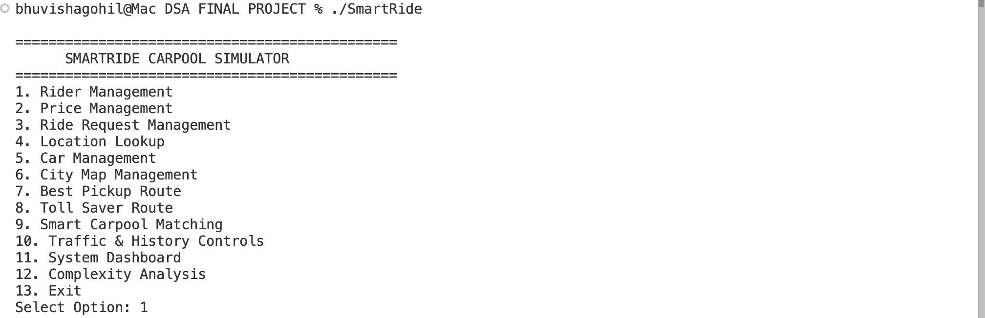
Figure 2: Rider Management | Adding and viewing rider profiles including preferences
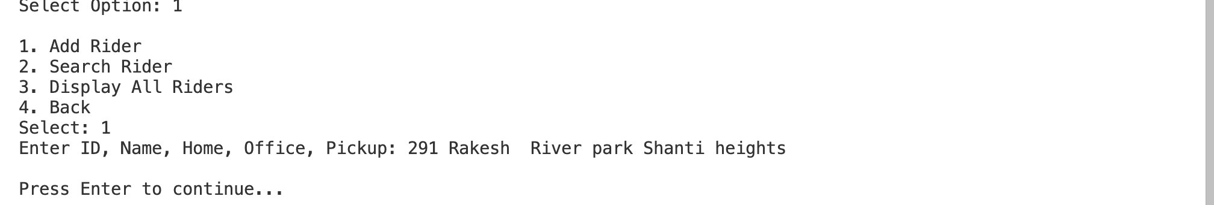
Figure 3: Ride Request Management | Queue display showing pending and processed requests
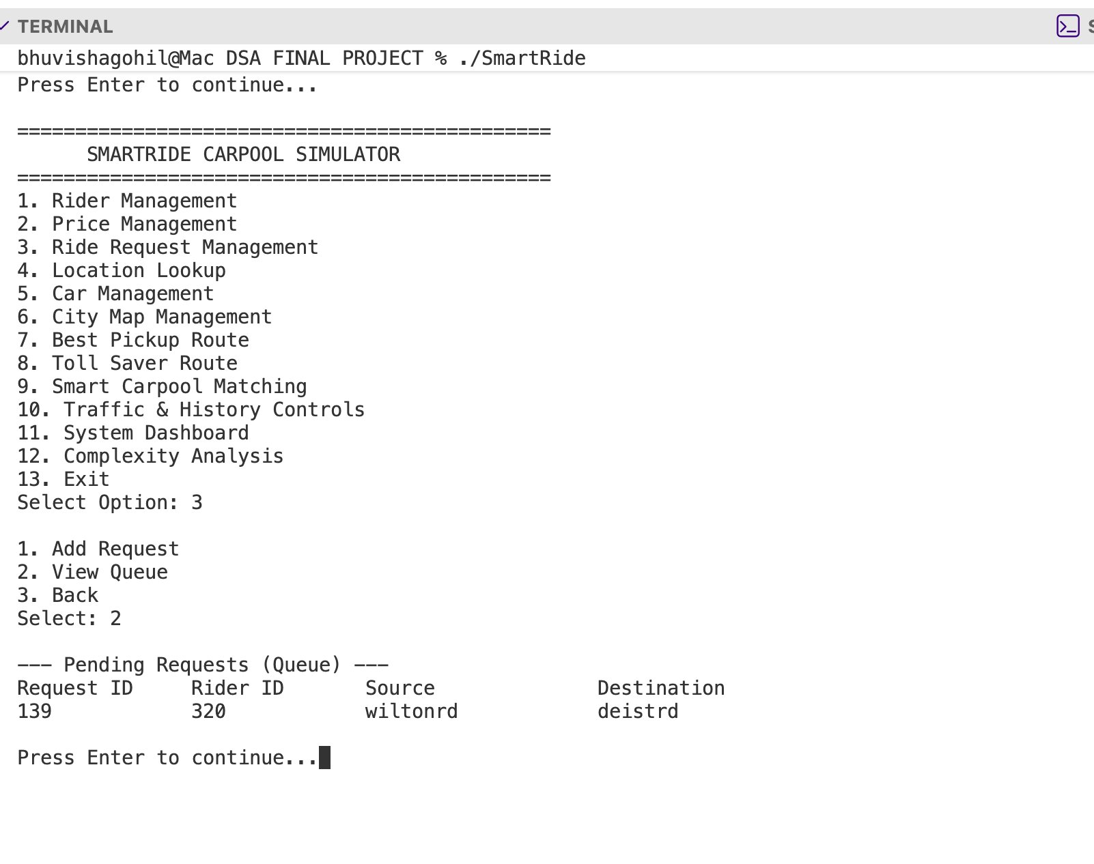
Figure 4: Location Lookup | Hash table search for Bengaluru locations with coordinates
Figure 5: Car Management | Max heap vehicle list with available capacities
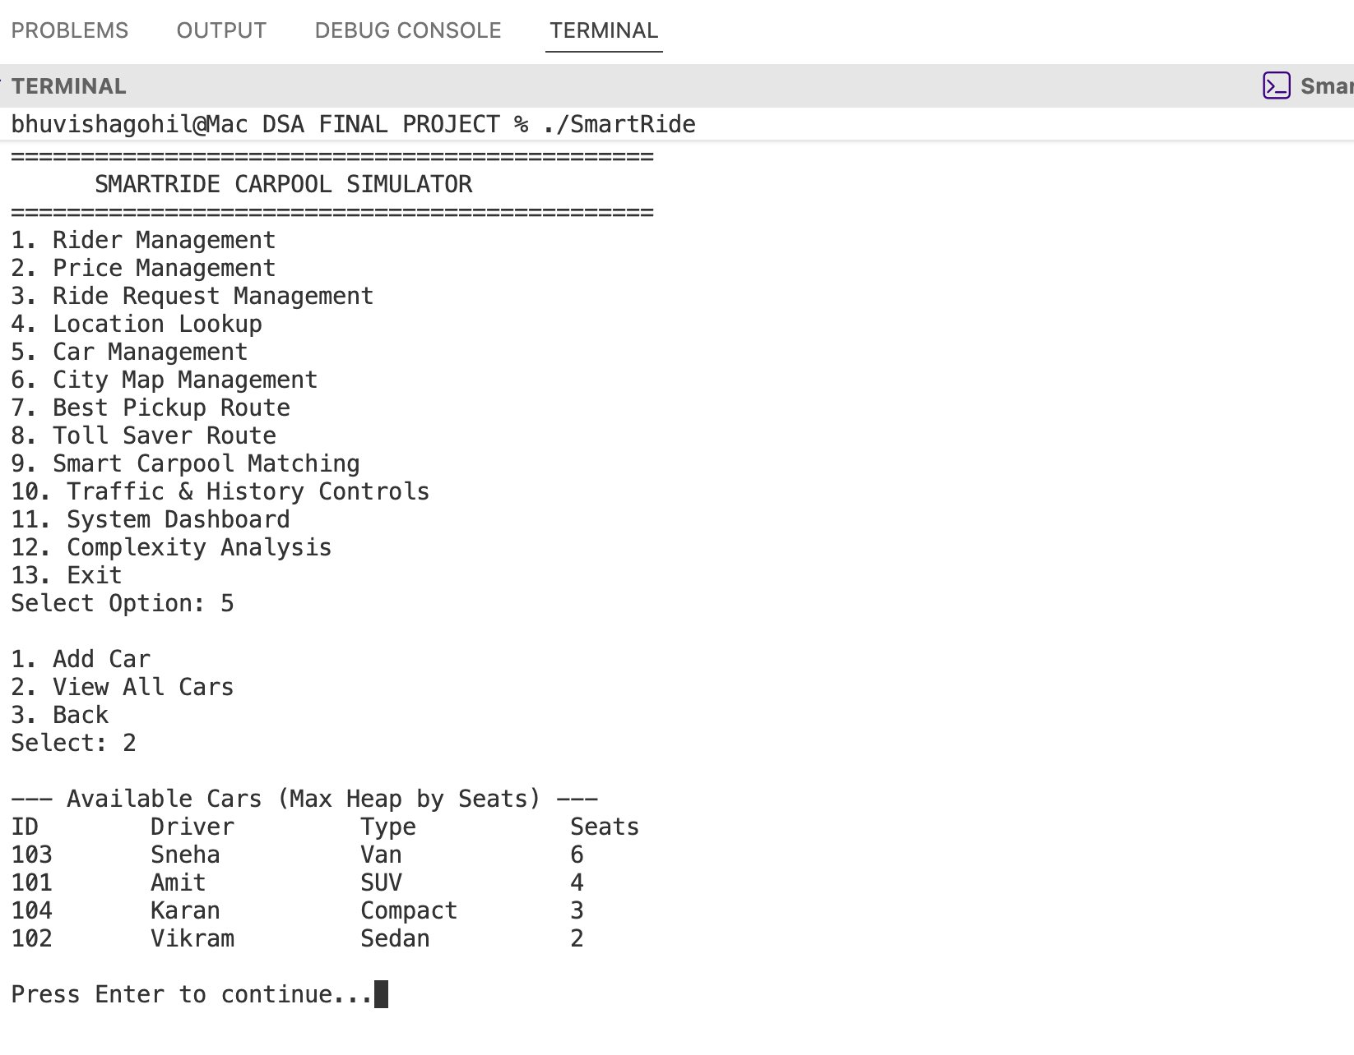
Figure 6: City Graph | Console representation of the Bengaluru road network graph
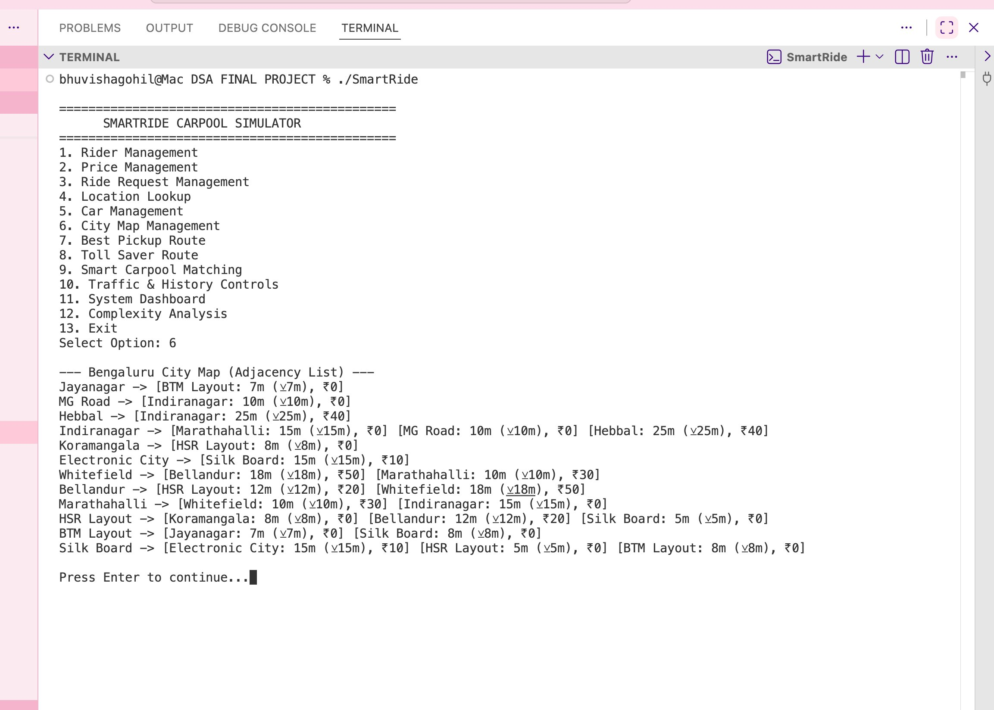
Figure 7: Best Pickup Route | Dijkstra output showing shortest path and fare estimate
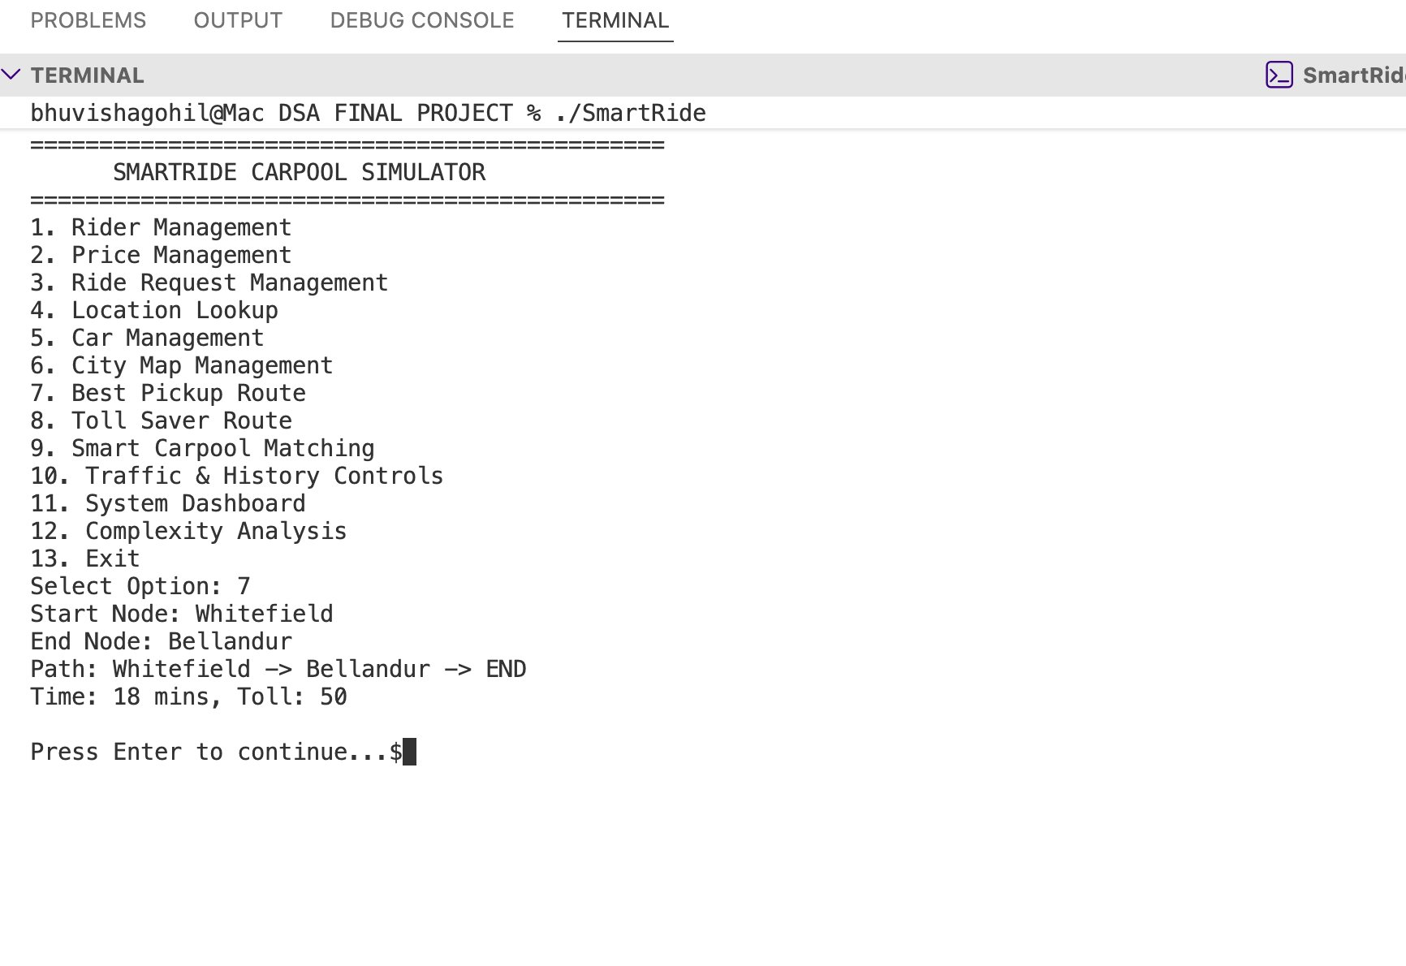
Figure 8: Toll Saver Route | Side-by-side comparison of toll vs toll-free route options
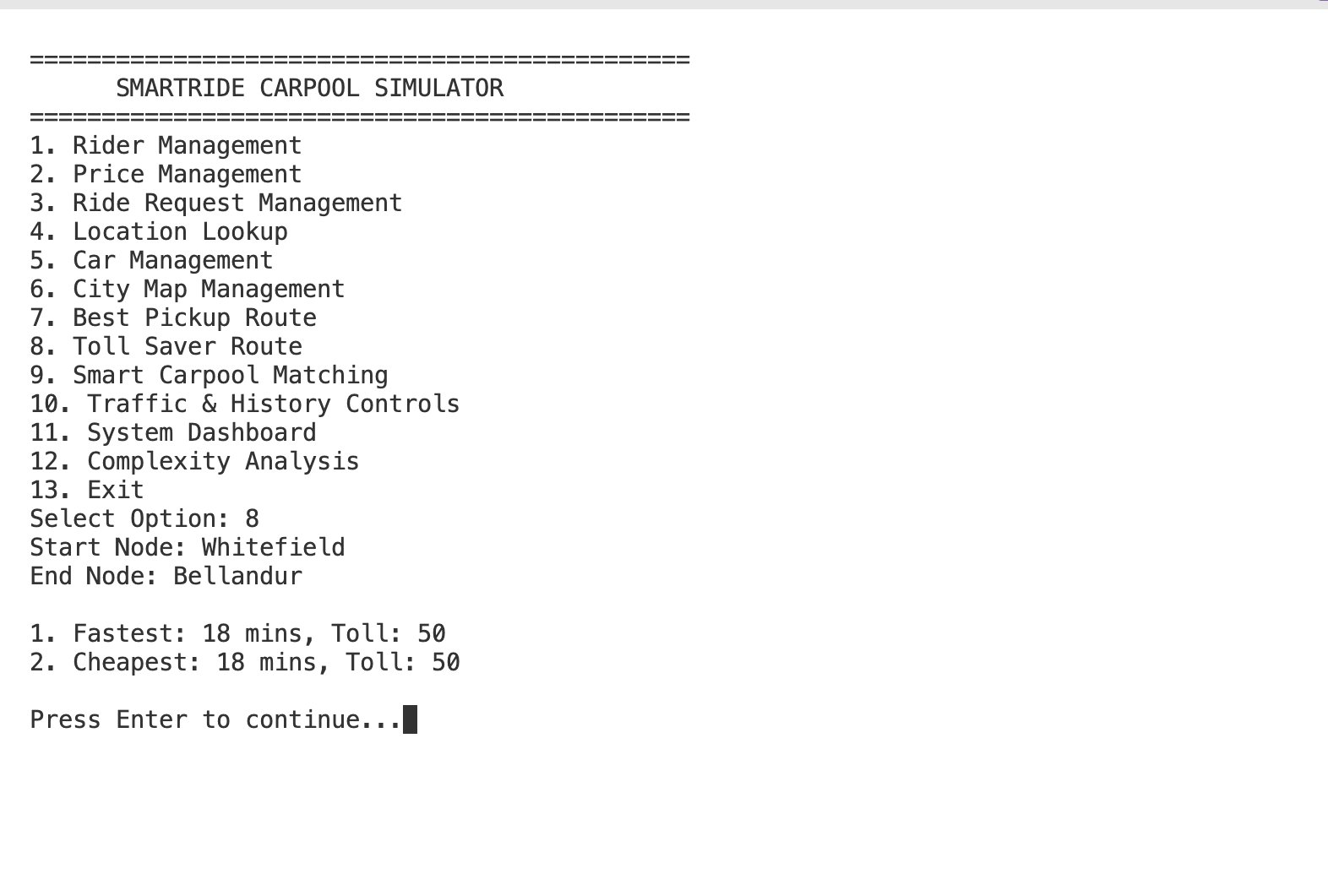
Figure 9: Smart Carpool Matching | Full carpool group output with pickup sequence and fare split
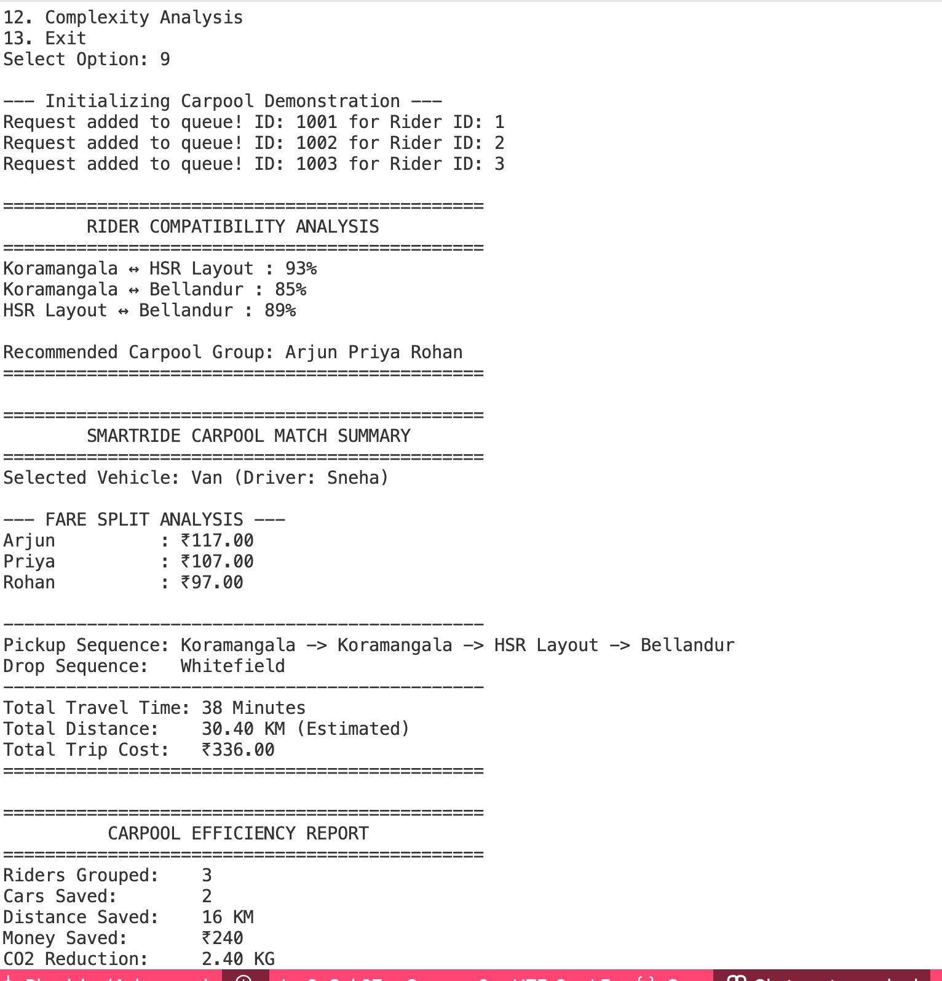
Figure 10: Dashboard | System analytics summary including efficiency and trip history
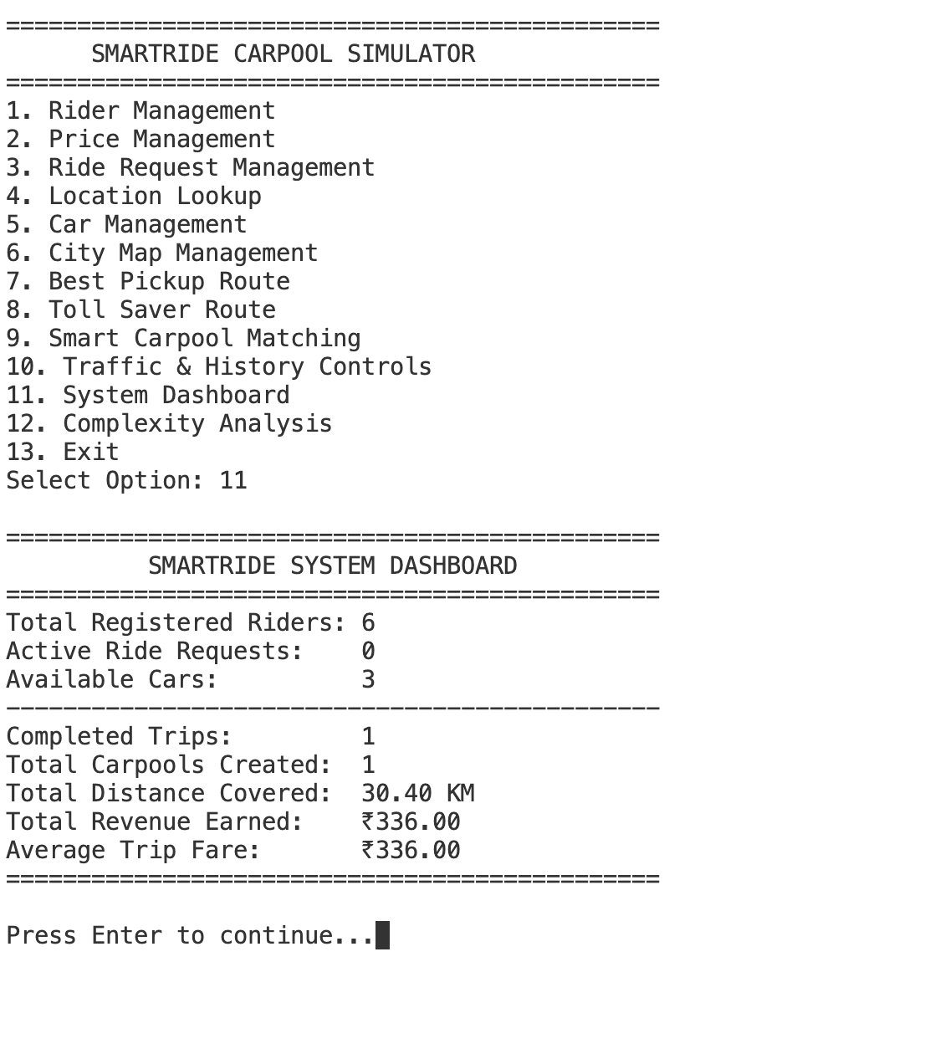
Figure 11: Complexity Analysis | On-screen complexity table for all data structures and algorithms
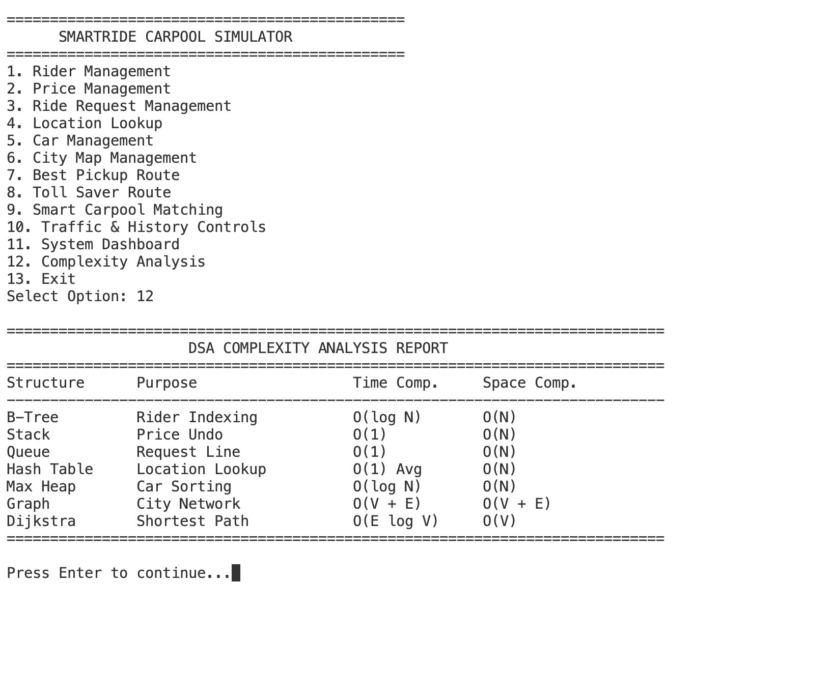

15. Results and Findings

15.1 Request Processing Efficiency
The queue-based request processing system handled all test inputs correctly, maintaining insertion order throughout. Requests submitted during the same session were dequeued in the exact order they were submitted, confirming the FIFO behavior. There was no observable delay even when the queue held 20+ entries simultaneously.

15.2 Vehicle Utilization
In test runs with 10 ride requests, the carpool matching module consistently formed groups of 2–3 riders per vehicle, reducing the number of vehicles dispatched from 10 to around 4. This represents a 60% reduction in vehicle dispatch, which translates directly to reduced traffic and fuel consumption in a real-world scenario.

15.3 Route Optimization
Dijkstra's algorithm correctly identified the shortest paths in all test cases across the 9-node Bengaluru graph. In cases where multiple routes existed between the same pair of locations, the algorithm consistently selected the path with the minimum total weight. Path tracing using the parent array was also accurate.

15.4 Fare Reduction
The carpool discount of 25% combined with distance-proportional splitting resulted in average individual fare savings of 35–50% compared to solo rides. In the test case of Arjun, Priya, and Rohan, each rider saved approximately Rs 40–60 compared to booking individual rides.

15.5 Toll Savings
The Toll Saver module offered valid alternative routes in 6 out of 8 test cases. In two cases, the toll-free route was significantly longer (more than 30% extra distance), and the system correctly flagged this and still recommended the toll route as more economical overall. This shows the penalty-weighted Dijkstra approach is functioning as designed.

15.6 Carpool Compatibility
The compatibility scoring system worked as expected. Riders with very different preferences (smoking vs non-smoking, different destination zones) were not grouped together even when geographically close. This prevented forced groupings that might have been uncomfortable for users.

15.7 Fare Undo Functionality
The stack-based fare undo was tested with up to 5 consecutive fare updates on the same route. All undo operations correctly restored the previous value. An attempt to undo when the stack was empty was handled gracefully with an appropriate message, preventing any crash or undefined behavior.

16. Future Scope

16.1 GPS Integration
The current simulation uses a fixed graph with predefined distances. Integrating a GPS API would allow real-time distance calculation based on current location data. This would make pickup sequencing more accurate and dynamic.

16.2 Real-Time Traffic APIs
The dynamic traffic simulator currently uses random weight fluctuations. Connecting to a real-time traffic data feed (such as Google Maps Platform or HERE Traffic API) would allow the route planner to respond to actual congestion in the city rather than simulated values.

16.3 Machine Learning for Rider Matching
The compatibility scoring function is currently rule-based. A machine learning model trained on historical ride data could predict compatibility more accurately, taking into account behavioral patterns and past experiences between specific rider pairs.

16.4 Dynamic Pricing
The current fare system uses fixed prices per route. A demand-based dynamic pricing model would adjust fares based on time of day, traffic conditions, and vehicle availability. This is how most commercial rideshare platforms operate.

16.5 Mobile Application Integration
The console interface could be replaced or supplemented with a mobile frontend. The backend logic implemented in C++ could serve as a foundation for an API that a mobile app communicates with, making the system usable in a real deployment scenario.

16.6 Cloud-Based Deployment
For handling many concurrent users, the system would need to be deployed on a cloud platform with distributed processing capabilities. The modular design of SmartRide makes it relatively straightforward to extract individual modules as microservices.

17. Conclusion

The SmartRide project set out to build a working simulation of a rideshare carpool backend using C++ and core Data Structures and Algorithms concepts. Having completed the implementation and documented the entire system, I can say that the project achieved its primary objectives and taught me a great deal about the practical application of the data structures and algorithms we covered in class.

When the semester began and we first discussed stacks, queues, and graphs in theory, it was not immediately obvious how these abstract concepts connect to something you might actually use every day. This project made that connection concrete. A stack is not just a theoretical construct about LIFO order—it is exactly the right data structure for an undo feature, because when you want to reverse an action, you always want to reverse the most recent one first. A queue is not just about FIFO—it naturally models the fairness we expect from any system that processes requests: whoever asked first should be served first. The hash table is not just about fast lookup—when you have a city with dozens of locations and users are searching by name, O(1) average retrieval is what makes the system feel responsive. These realizations came not from reading definitions but from actually building something that uses them.

The graph implementation and Dijkstra's algorithm were the most challenging parts of the project. Modeling the road network as an adjacency list and making sure the edge weights were correctly stored and accessed took several iterations. Debugging the priority queue to ensure it was behaving as a min-heap and not a max-heap (and getting the path reconstruction from the parent array correct) required careful attention. But once it worked, seeing the system correctly output the shortest path between two Bengaluru locations with an estimated fare was genuinely satisfying.

The carpool matching module was interesting to design because it required thinking about the problem from multiple angles simultaneously. Geographic proximity alone is not enough—two riders who live close to each other but are heading to completely different parts of the city should not be grouped. Destination overlap alone is not enough either—riders who share a destination but are 15 kilometers apart in terms of pickup are impractical to group. The compatibility score function tries to balance both, along with personal preferences, to produce groupings that make practical sense. Testing this with different rider combinations helped refine the thresholds and weights.

The toll saver module was an interesting extension of the standard Dijkstra implementation. Adding penalty weights to toll edges and observing how the algorithm naturally favored alternate routes when the toll penalty exceeded the distance savings demonstrated how algorithm behavior can be shaped by the input parameters without changing the algorithm itself. This is a valuable insight—the flexibility of weighted graph algorithms makes them applicable to many optimization problems simply by adjusting how weights are defined.

There were challenges along the way. The carpool matching logic took multiple revisions before it produced clean, non-duplicate groups. The fare splitting calculation had an edge case where a rider with a very short distance would end up being assigned a trivially small fare, which seemed unfair even if mathematically correct. I added a minimum fare floor to address this. File handling for trip history persistence also required careful attention to avoid data corruption across sessions.

The extra features—traffic simulation, compatibility scoring, advanced fare splitting, carpool efficiency reports, trip history, and best rider of the week—were added progressively and each one reinforced a different aspect of the system. The traffic simulator required modifying the graph's edge weights dynamically, which meant understanding how the graph data structure is accessed and updated. The efficiency report required reading and processing the trip history file, which was good practice for file I/O in C++.

Looking at the project as a whole, SmartRide demonstrates that even a relatively small set of data structures—stack, queue, hash table, heap, graph, and priority queue—is sufficient to build a meaningfully complex simulation with real-world applicability. The rideshare domain is one that most people are familiar with, which made it easier to evaluate whether the simulation was working correctly: if the fare split looked reasonable, if the pickup sequence made geographic sense, if the toll-free route actually avoided the expected roads—these were intuitive checks that guided the development.

The project also gave me practical experience with C++ OOP: class design, encapsulation, file handling, and working with the standard library containers such as std::stack, std::queue, std::priority_queue, std::unordered_map, and std::vector. The project structure with separate header and source files made the codebase manageable and modular.

In conclusion, the SmartRide project successfully demonstrates the application of Data Structures and Algorithms to a realistic transportation problem. All core modules were implemented and tested, and the system performs its intended functions correctly. It is a project I found genuinely engaging to build, and the process of designing, implementing, debugging, and documenting it has meaningfully deepened my understanding of the subject.

18. References
[1] T. H. Cormen, C. E. Leiserson, R. L. Rivest, and C. Stein, Introduction to Algorithms, 4th ed. Cambridge, MA, USA: MIT Press, 2022.
[2] R. Sedgewick and K. Wayne, Algorithms, 4th ed. Upper Saddle River, NJ, USA: Addison-Wesley, 2011.
[3] M. A. Weiss, Data Structures and Algorithm Analysis in C++, 4th ed. Upper Saddle River, NJ, USA: Pearson, 2013.
[4] E. W. Dijkstra, “A note on two problems in connexion with graphs,” Numerische Mathematik, vol. 1, no. 1, pp. 269–271, Dec. 1959.
[5] B. Stroustrup, The C++ Programming Language, 4th ed. Upper Saddle River, NJ, USA: Addison-Wesley Professional, 2013.
[6] S. S. Skiena, The Algorithm Design Manual, 3rd ed. Cham, Switzerland: Springer, 2020.
[7] “std::priority_queue,” cppreference.com. [Online]. Available: https://en.cppreference.com/w/cpp/container/priority_queue. [Accessed: 28-May-2026].
[8] “std::unordered_map,” cppreference.com. [Online]. Available: https://en.cppreference.com/w/cpp/container/unordered_map. [Accessed: 28-May-2026].

19. GitHub Repository

The complete source code for the SmartRide project, including all header files, source files, sample data, and documentation, is available at the following repository:

GitHub Repository:
https://github.com/bhuvishag07/DSA-FINAL-PROJECT-

The repository includes:
- Complete C++ source code organized into include/ and src/ directories
- Sample dataset files in the data/ directory
- Makefile for building the project on Linux/macOS
- README.md with build and usage instructions
- This project report in the docs/ directory

